Bahria University,

Karachi Campus



LAB EXPERIMENT NO.

**04**

LIST OF TASKS

|  |  |
| --- | --- |
| TASK NO | OBJECTIVE |
| 1 | **Write a python program for solving the following non-linear equations using NewtonRaphson method correct up to 5 decimal places: a. cosx = xex (having initial guess x0 = 1)  b. x−2sinx−3 = 0 (having initial guess x0 = 4)** |
| 2 | **Write a python program for solving the following non-linear equations using fixed point iterative method correct up to 3 decimal places: a. cos x = 3x – 1  b. 2x3 – 7x2 – 6x + 1 = 0** |

**Task 1: Write a python program for solving the following non-linear equations using Newton Raphson method correct up to 5 decimal places:  
a. cosx = xe^x (having initial guess x0 = 1)   
b. x−2sinx−3 = 0 (having initial guess x0 = 4)**

**Solution**

**a. cosx = xe^x (having initial guess x0 = 1)**

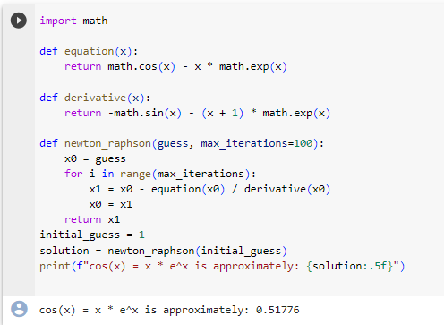

**b. x−2sinx−3 = 0 (having initial guess x0 = 4)**

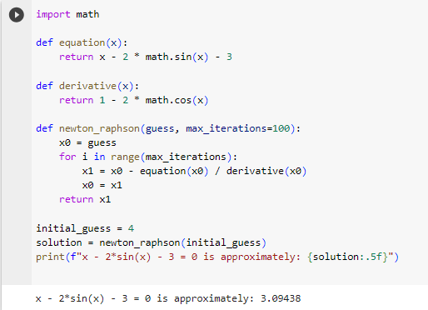

**Task 2: Write a python program for solving the following non-linear equations using fixed point iterative method correct up to 3 decimal places:  
a. cos x = 3x – 1   
b. 2x3 – 7x2 – 6x + 1 = 0**

**Solution**

**a. cos x = 3x – 1**

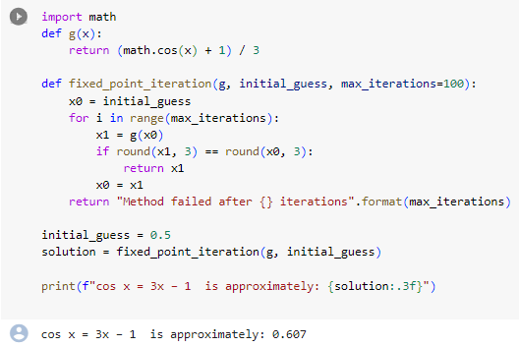

**b. 2x3 – 7x2 – 6x + 1 = 0**

